Blockchain-Based Organic Farming Traceability and Supply Chain Transparency Platform
MID TERM VII SEMESTER SYNOPSIS REPORT
Submitted in partial fulfillment of the requirement of the degree of

BACHELORS OF TECHNOLOGY
to
The NorthCap University
by
Nakshatra 23CSU207

Under the supervision of
Dr Poonam & Dr Sneha Kandacharam
Assistant Professor,
Department of Computer Science and Engineering

Department of Computer Science and Engineering
School of Engineering and Technology
The NorthCap University, Gurugram- 122001, India
Session 2026-2027

CERTIFICATE

This is to certify that the Project Synopsis entitled, “Blockchain-Based Organic Farming Traceability and Supply Chain Transparency Platform” submitted by “Nakshatra” to The NorthCap University, Gurugram, India, is a record of bonafide synopsis work carried out by them under my supervision and guidance and is worthy of consideration for the partial fulfilment of the degree of Bachelor of Technology in Computer Science and Engineering of the University.

______________________ ______________________
Dr Poonam Dr Sneha Kandacharam

Date: ………………

INDEX

- Abstract

- Introduction (description of broad topic)

  - Background
  - Feasibility Study

- Study of Existing Solution (implementation-based project)/Literature Survey (research based)
- Comparison with existing software solutions (implementation based)/Literature (research based)
- Gap Analysis
- Problem Statement
- Objectives
- Outcomes
- Gantt Chart
- Responsibility Chart
- References
- Annexure I: Front page of plagiarism report by guide
- Annexure II: Screenshots of Faculty mail / comments from guide

Important Notes:
*Overall and AI Plagiarism of the report should be equal to or less than 10%: provided by guide
*Font style: Times New Roman, Font size: 12, 14 (heading)
*Synopsis report size should be of at least 10-12 pages

1. ABSTRACT

Organic farming has gained importance because consumers are increasingly concerned about food quality, agricultural practices, product origin and authenticity. However, an organic agricultural product normally passes through several stages before reaching the final consumer. These stages may include farming, harvesting, processing, packaging, transportation, distribution and retail. Information generated at these stages is often maintained separately by different stakeholders. As a result, consumers may find it difficult to obtain a complete and trustworthy history of a product.
The proposed project, “Blockchain-Based Organic Farming Traceability and Supply Chain Transparency Platform,” aims to develop a web-based platform for recording and tracing important events in the organic agricultural supply chain. The proposed system will use blockchain technology and smart contracts to maintain a tamper-evident record of selected supply-chain events. A conventional database will be used for application data, while blockchain will be used for important event information and cryptographic hashes.
The platform will provide different roles for farmers, processors, distributors, retailers, certification authorities and administrators. Farmers will be able to register products and batches, while other supply-chain participants will update the status of a batch as it moves through the supply chain. A QR code associated with a product batch will allow consumers to access a public traceability page and view the recorded product journey.
The project will also investigate the use of SHA-256 hashing for certificate/document integrity verification. Instead of storing complete documents on blockchain, a cryptographic hash can be recorded and later compared with a newly generated hash to identify possible modifications.
The proposed system is intended to improve supply-chain transparency, traceability and auditability. However, blockchain itself cannot prove that a product is physically organic. The reliability of the information still depends on the participating stakeholders and certification processes. Therefore, the project focuses on providing a trustworthy digital record of submitted and verified information rather than claiming that blockchain independently verifies organic farming practices.

2. INTRODUCTION

2.1 Background

Agriculture is an important part of the global food system, and the movement of agricultural products involves multiple stakeholders. A product may originate from a farm and then move through collection centres, processors, distributors, retailers and finally consumers. During this journey, different types of information are generated, including product origin, harvesting information, processing details, transportation information, certification records and retail information.
Traceability refers to the ability to follow the movement and history of a product through different stages of a supply chain. In the case of organic products, traceability is particularly relevant because consumers are interested not only in the product itself but also in its origin and certification.
Traditional traceability systems generally rely on centralized databases. Such systems can be useful for maintaining records, but information is usually controlled by specific organizations. When several independent stakeholders are involved, maintaining a common and trusted history can become difficult.
Blockchain technology provides an alternative approach. A blockchain is a distributed ledger in which transactions are recorded and linked using cryptographic techniques. Once a transaction has been accepted into the ledger, changing historical information becomes difficult without detection. Blockchain therefore has potential applications in supply-chain traceability, where multiple organizations need access to a consistent record.
Recent research has examined blockchain for food and agricultural traceability. A systematic review published in 2026 identified blockchain-based food supply-chain traceability as an active research area and highlighted its connection with food safety, authenticity, security and sustainable supply governance. Another systematic review reported that blockchain can support food safety and traceability but that adoption still faces technical and organizational challenges.
Research specifically related to organic food has also examined the relationship between blockchain-enabled traceability and consumer trust. A 2024 study found that blockchain-enabled food traceability can positively influence trust in the organic food chain and consumer purchase behaviour.
Therefore, this project proposes an implementation-oriented platform that combines blockchain, smart contracts, conventional database technology and QR-based consumer access.

2.2 Proposed Concept

The basic concept of the proposed system is:

Farmer → Processor → Distributor → Retailer → Consumer

At different stages, authorized participants record important events related to a product batch.
For example:
Farmer
- Creates product batch
- Provides farm information
- Records harvesting information
- Associates certification information
↓
Processor
- Receives the batch
- Records processing
- Records packaging
↓
Distributor
- Records shipment
- Records transportation
- Records delivery
↓
Retailer
- Receives the product
- Marks the batch available for sale
↓
Consumer
- Scans QR code
- Views product information
- Views supply-chain timeline
- Checks available verification information
The backend will communicate with both the PostgreSQL database and the blockchain network. Normal application information will remain in the database, while important supply-chain events and hashes will be recorded through smart contracts.

2.3 Feasibility Study

2.3.1 Technical Feasibility

The project is technically feasible using currently available open-source technologies.
The proposed technology stack includes:
- React/Vite for frontend development
- Node.js and Express.js for backend development
- PostgreSQL for application data
- Solidity for smart-contract development
- Hardhat for local blockchain development and testing
- ethers.js for blockchain interaction
- QR-code technology for consumer traceability
- SHA-256 for document/certificate hashing
The first version will be tested using a local Ethereum-compatible blockchain network. This reduces the dependency on public blockchain infrastructure during development.

2.3.2 Economic Feasibility
The project can be developed at relatively low cost because the major software components are open source.
The prototype can be developed using:
- Open-source development frameworks
- Local blockchain infrastructure
- PostgreSQL
- Free development tools
- Local testing environments
No paid blockchain transactions are required during the initial development and testing stage.

2.3.3 Operational Feasibility
The system is operationally feasible because each participant will receive a role-specific interface.
The proposed roles are:
- Farmer
- Processor
- Distributor
- Retailer
- Certifier
- Administrator
- Consumer
The consumer interface will be simplified. A consumer will not need technical knowledge of blockchain. The QR code will provide access to the public traceability page.

2.3.4 Schedule Feasibility
The project can be completed in phases.
The initial phase will focus on literature survey, requirements and architecture. The next phase will include database, backend, frontend and smart-contract development. Integration, testing and documentation will follow.
The project timeline is planned according to the university's major project schedule and will be adjusted based on supervisor feedback.

3. STUDY OF EXISTING SOLUTIONS / LITERATURE SURVEY
Blockchain-based agricultural traceability has become an active research area. Existing literature shows that blockchain can be useful for maintaining transparent records across supply-chain participants.
Study 1: Feng et al. (2020)
Feng et al. reviewed the use of blockchain technology for improving agri-food traceability. Their study discusses how traditional centralized traceability systems can limit access to transaction information and make it difficult for consumers to follow product origins. The study identifies transparency and security as important potential benefits of blockchain-based traceability. It also discusses challenges associated with implementing blockchain in food supply chains.
Relevance to proposed project:
This work supports the use of blockchain for maintaining transparent supply-chain information.

Study 2: Prashar et al. (2020)
Prashar et al. proposed a blockchain-based traceability and visibility system for agricultural products, with a focus on the Indian context. Their system uses smart contracts to manage communication and transactions between supply-chain stakeholders. The study demonstrates how blockchain can be used to provide traceability and integrity for agricultural products.
Relevance to proposed project:
The study is particularly relevant because it considers agricultural supply chains in India and demonstrates the use of blockchain and smart contracts.

Study 3: Blockchain and Agricultural Supply Chains
Research examining blockchain and agricultural supply-chain traceability has identified transparency, reliability and immutability as important properties of blockchain. However, researchers also note that many proposed systems remain at an early stage and that practical implementation remains an important challenge.
Relevance:
This supports the need for implementation-oriented projects rather than only conceptual blockchain frameworks.

Study 4: Blockchain and Sustainable Agri-Food Supply Chains
A systematic review of blockchain in sustainable agri-food supply chains identified benefits including improved traceability and transparency, while also highlighting challenges such as scalability, privacy, cost and connectivity.
Relevance:
These challenges need to be considered when designing the proposed system. The project therefore avoids storing large files directly on blockchain and uses PostgreSQL for normal application data.

Study 5: Blockchain and Organic Food Consumer Trust
A 2024 study examined blockchain-enabled food traceability in relation to organic food consumption. The study reported that blockchain-enabled traceability can strengthen consumer trust in the organic food chain.
Relevance:
This supports the proposed consumer-facing QR traceability feature.

Study 6: Blockchain Traceability in Agri-Food
Pan et al. examined blockchain traceability and consumer perceptions in the agri-food context. Their work highlights the importance of the integrity and clarity of traceability information and notes that consumers can still have concerns about whether blockchain-based information is reliable.
Relevance:
This supports the need to distinguish between blockchain record integrity and the actual truthfulness of physical-world information.

Study 7: Blockchain-Based Agricultural Traceability Architecture
A 2023 study proposed a peer-to-peer blockchain architecture for agricultural product traceability and explored identity management and blockchain performance. The research demonstrates the possibility of using blockchain for trusted agricultural traceability while also considering scalability and identity issues.
Relevance:
The proposed project can adopt a simpler architecture suitable for a B.Tech implementation while retaining the basic idea of trusted participant-based traceability.

Study 8: Blockchain Characteristics in Agri-Food
A systematic review published in 2024 identified transparency, immutability, redundancy, versatility and automation among the characteristics relevant to blockchain applications in the agri-food sector. The review also points out that technical and environmental concerns require further research.
Relevance:
The proposed platform focuses mainly on transparency, traceability, immutability/tamper evidence and automation through smart contracts.

Study 9: Blockchain and Smart Contracts in Agricultural Supply Chains
Research published in 2024 examined the use of blockchain and smart contracts in agricultural supply chains, particularly for traceability, product quality and origin information.
Relevance:
This supports the use of Solidity smart contracts for recording important supply-chain events.

Study 10: Recent Systematic Research
A 2026 systematic literature study based on 620 Scopus-indexed publications found increasing research interest in combining blockchain with technologies such as IoT and AI for food supply-chain traceability. It also identified food safety, authenticity, security and sustainable supply governance as important research themes.
Relevance:
The findings indicate that blockchain traceability remains an active research area and that integration with additional technologies can form future extensions of the proposed platform.

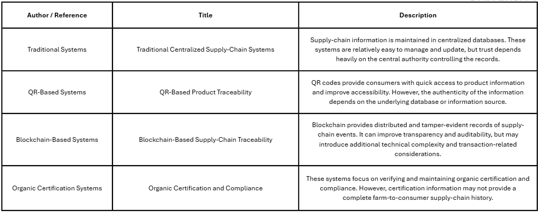

4. COMPARISON WITH EXISTING SOLUTIONS
Existing blockchain-based agricultural traceability approaches demonstrate the usefulness of distributed ledgers for recording product movement, improving transparency and maintaining traceable records. However, many approaches focus primarily on recording transactions or supply-chain events. The proposed platform focuses on combining traceability, certification integrity and consumer-level access within a single web-based system.
The main differentiation of the proposed platform is therefore not blockchain alone, but the integration of multiple mechanisms:
Blockchain + Smart Contracts + Multi-Stage Traceability + Certificate Hash Verification + QR-Based Consumer Access

4.1 Integrated End-to-End Traceability
The proposed platform records the journey of an agricultural product from the farmer through processing, distribution and retail.
Instead of maintaining isolated records at individual stages, the system associates important supply-chain events with a common product batch identifier. This creates a continuous digital timeline for the batch.
For example:
Farmer → Processor → Distributor → Retailer → Consumer
Each authorized participant can record relevant information when the batch changes hands. The resulting timeline can be viewed by authorized users and selected information can be made available to consumers.
This provides a more complete view of product provenance than a system that records information only at one stage of the supply chain.

4.2 Certificate Integrity Verification
Organic certification is an important component of agricultural product traceability. The proposed system therefore includes a certificate/document integrity mechanism.
Instead of storing the complete certificate document on the blockchain, the system generates a SHA-256 cryptographic hash of the document. The resulting hash is associated with the relevant product batch.
When verification is required, the certificate can be hashed again and the newly generated hash can be compared with the previously recorded value.
If the hashes match, the document content has remained unchanged from the version whose hash was recorded.
This approach combines conventional document storage with blockchain-based integrity verification while avoiding the storage of large files directly on the blockchain.

4.3 Role-Based Multi-Stakeholder Platform
The proposed system is designed for different participants in the agricultural supply chain rather than treating the entire system as a single-user application.
The proposed roles include:
- Farmer
- Processor
- Distributor
- Retailer
- Certifier
- Administrator
- Consumer
Each role receives access to functions relevant to its responsibilities. For example, farmers can create batches, processors can record processing events, distributors can update transportation information, and certifiers can associate certification information with a product.
This role-based design provides accountability regarding which participant records a particular supply-chain event.

4.4 Consumer-Level QR Traceability
Another important feature is direct consumer access to product provenance.
Each product batch can be associated with a QR code. When scanned, the QR code directs the consumer to a public traceability page containing appropriate product information and the recorded supply-chain timeline.
The consumer does not need to understand blockchain technology or interact directly with a blockchain wallet.
The purpose of the QR system is therefore to convert the technical blockchain record into a simple consumer-facing traceability interface.

4.5 Separation of Application Data and Blockchain Data
The proposed platform does not attempt to store every piece of information directly on the blockchain.
Application and operational data can be maintained in PostgreSQL, while selected supply-chain events, identifiers and cryptographic hashes are recorded through smart contracts.
This hybrid architecture reduces unnecessary blockchain storage and makes the system more practical for a prototype implementation.

4.6 Distinction Between Data Integrity and Physical-World Authenticity
An important design consideration of the proposed platform is that blockchain does not independently prove that a physical agricultural product is organic.
Blockchain can provide evidence that a particular digital record has not been modified after being recorded. However, the correctness of the original information still depends on the person or organization submitting it and on the relevant certification or inspection process.
The proposed system therefore focuses on tamper-evident digital traceability and verification of submitted records, rather than claiming that blockchain alone can certify organic farming practices.
This distinction makes the proposed approach more realistic and technically defensible.
The proposed platform combines features that are often treated separately in existing approaches.

5. GAP ANALYSIS
The literature survey indicates that blockchain has significant potential for agricultural and food traceability. However, several gaps remain.
Gap 1: Fragmented Supply-Chain Information
Different stakeholders may maintain their own records. This makes it difficult to obtain a complete history of a product.
Gap 2: Limited Consumer-Level Traceability
Some blockchain systems focus primarily on communication between organizations and provide limited consumer-oriented interfaces.
Gap 3: Certification Integration
Organic certification is an important part of consumer trust, but certification information is not always integrated with the complete supply-chain history.
Gap 4: Document Integrity
Simply storing a certificate in a database does not provide a strong mechanism for detecting later changes. Cryptographic hashing can provide an additional integrity check.
Gap 5: Practical Implementation
A significant portion of existing literature focuses on frameworks, models and conceptual architectures. There is still value in developing a complete prototype that combines frontend, backend, database, smart contracts and QR-based consumer access.
Gap 6: Blockchain Does Not Solve the Physical-World Trust Problem
Blockchain can protect the integrity of recorded information, but it cannot determine whether a farmer's original input was truthful. This creates a distinction between data integrity and data authenticity.
Proposed Research/Implementation Gap
There is a need for a practical integrated platform that combines farmer-level product provenance, multi-stage supply-chain event recording, certification hash verification, blockchain-based auditability and QR-based consumer traceability within a single application.

6. PROBLEM STATEMENT
Organic agricultural products pass through multiple stages before reaching consumers. During this process, information regarding product origin, harvesting, processing, certification, transportation and retail may be recorded separately by different stakeholders.
This fragmented approach makes it difficult for consumers to obtain a complete and easily verifiable product history. Traditional centralized systems also depend on the organization responsible for maintaining the database, while QR-based systems may provide access to information without necessarily providing strong evidence of data integrity.
Therefore, there is a need for a system that can provide:
- End-to-end product traceability
- Transparent supply-chain event history
- Tamper-evident records
- Certificate/document integrity verification
- Role-based access for supply-chain participants
- Simple consumer access through QR codes
The proposed project addresses this problem through a blockchain-based web platform that records important supply-chain events using smart contracts and provides a public traceability interface for consumers.

7. OBJECTIVES
The major objectives of the proposed project are:
Objective 1
To design and develop a blockchain-based platform for tracing organic agricultural products across multiple supply-chain stages.
Objective 2
To implement smart contracts for recording important events associated with product batches.
Objective 3
To provide a tamper-evident and auditable history of product movement from farm to retail.
Objective 4
To implement SHA-256 based certificate/document hashing for verifying document integrity.
Objective 5
To develop QR-code-based consumer access to product provenance and supply-chain information.
Objective 6
To implement role-based access for farmers, processors, distributors, retailers, certifiers and administrators.
Objective 7
To evaluate the proposed platform in terms of traceability, transparency, data integrity, usability and technical feasibility

8. OUTCOMES
The expected outcomes of the project are:
- A functional web-based agricultural traceability platform.
- A blockchain smart contract for recording supply-chain events.
- A PostgreSQL database for storing application and operational information.
- Role-based dashboards for different supply-chain participants.
- Product batch creation and tracking functionality.
- QR-code generation for product traceability.
- A public consumer traceability page.
- Certificate/document hash generation and verification.
- Blockchain transaction records associated with supply-chain events.
- An administrative dashboard for monitoring users, products and events.
- A working prototype demonstrating the journey:
Farmer → Processor → Distributor → Retailer → Consumer
- Experimental evaluation of the system's functionality and performance.

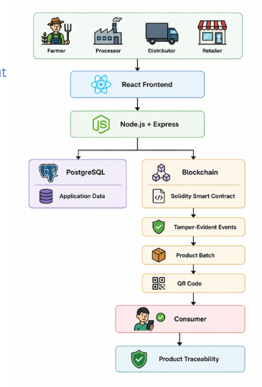
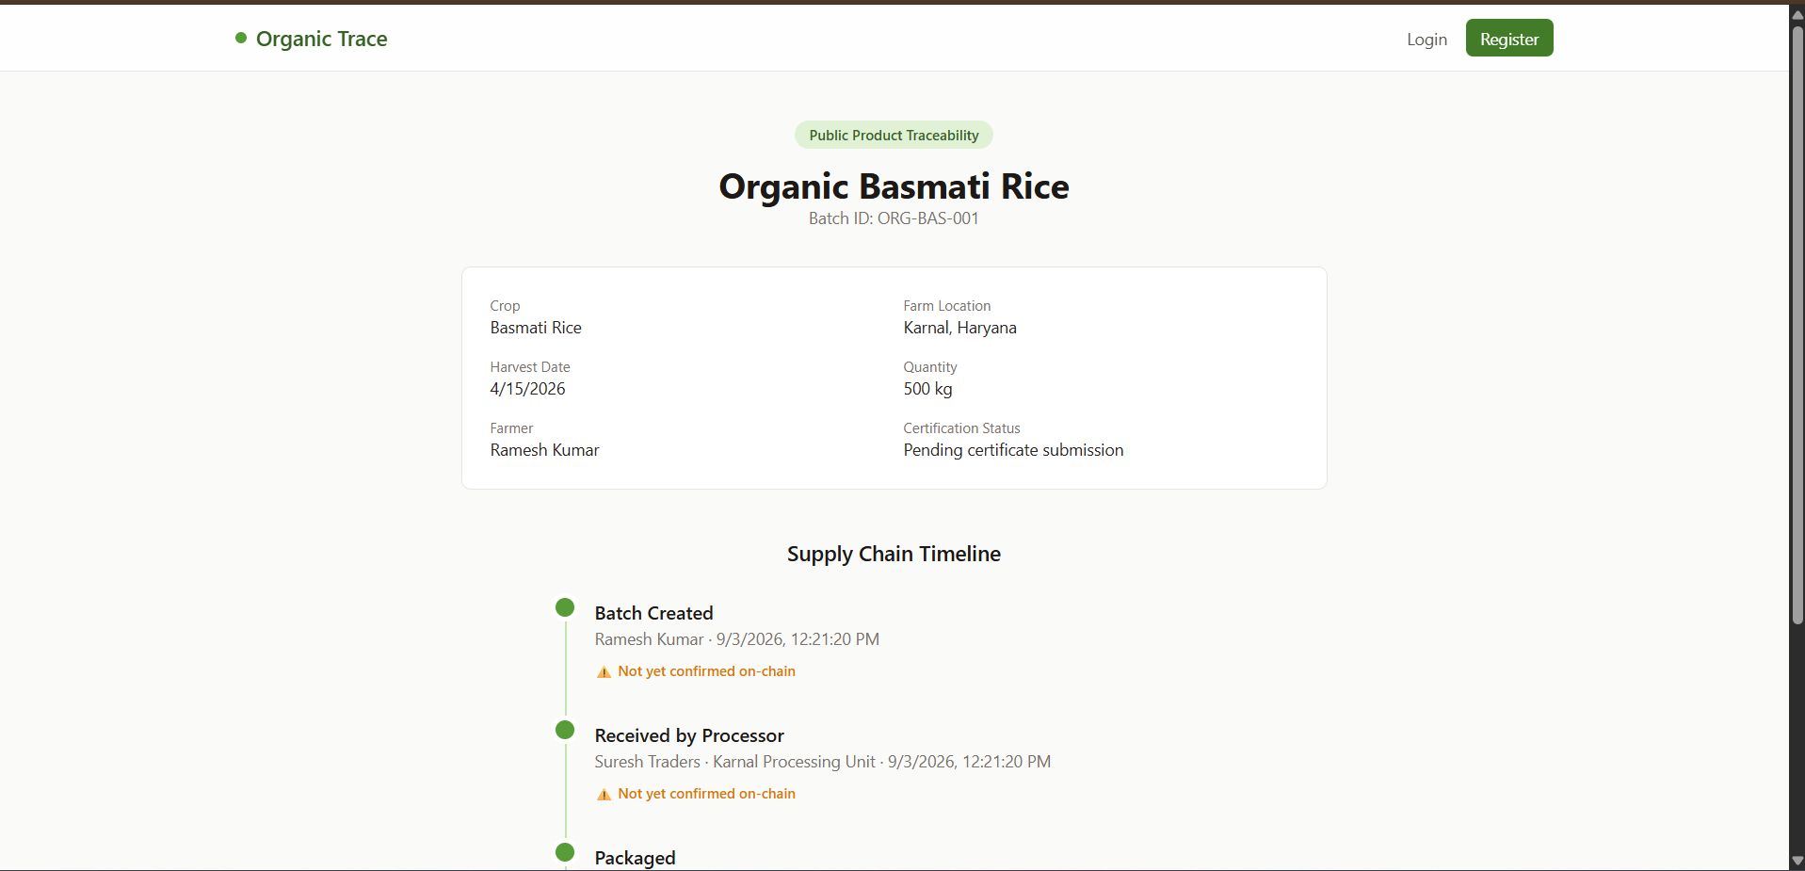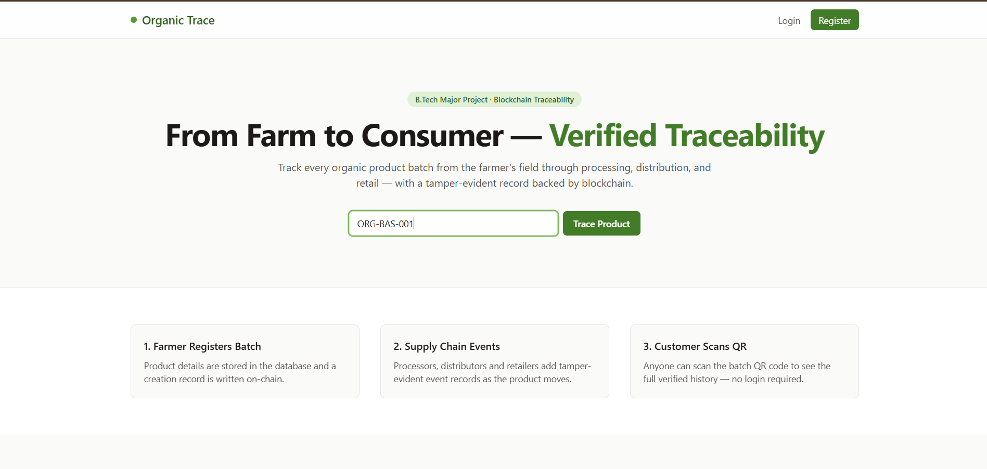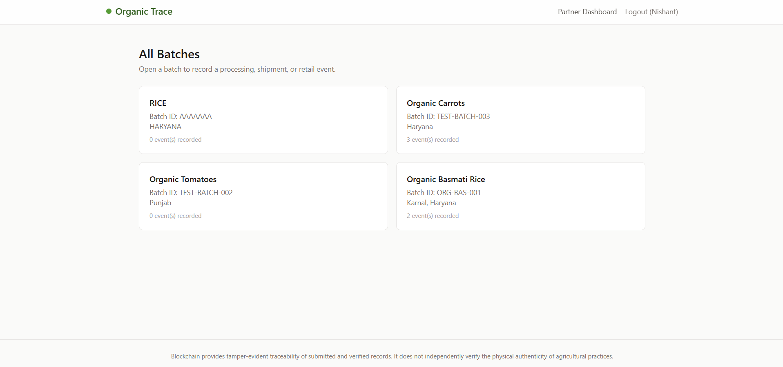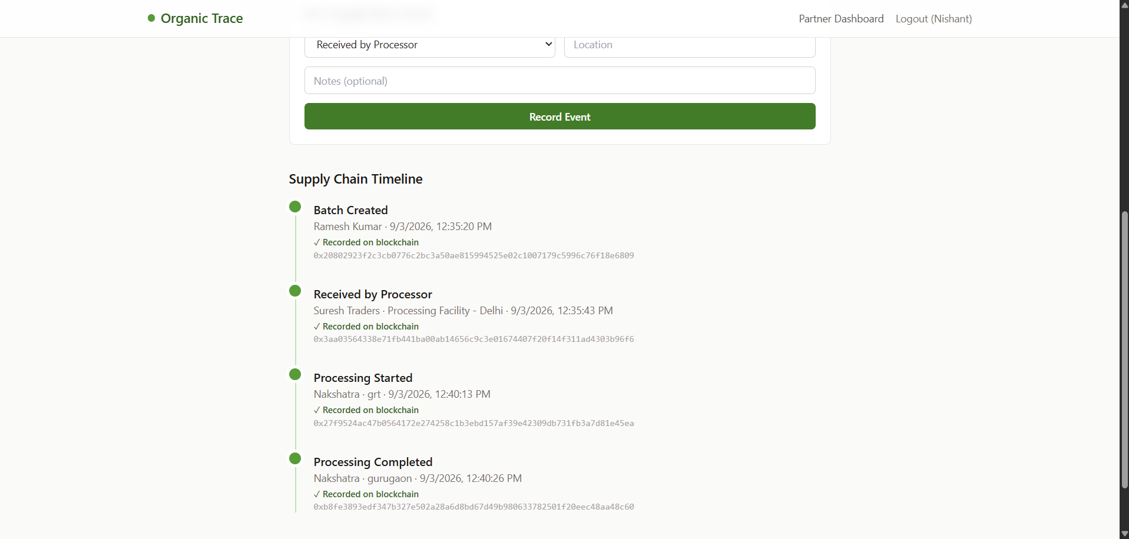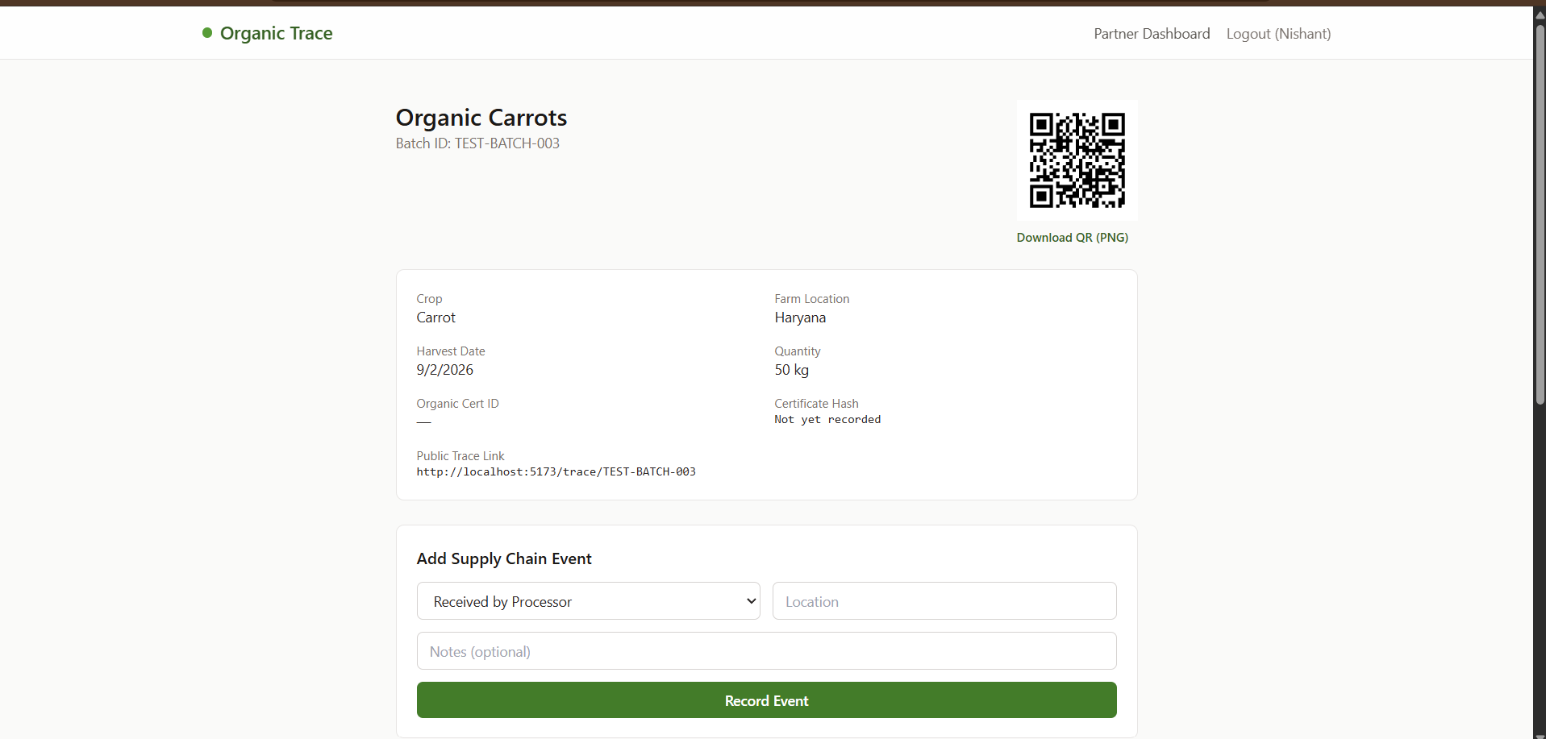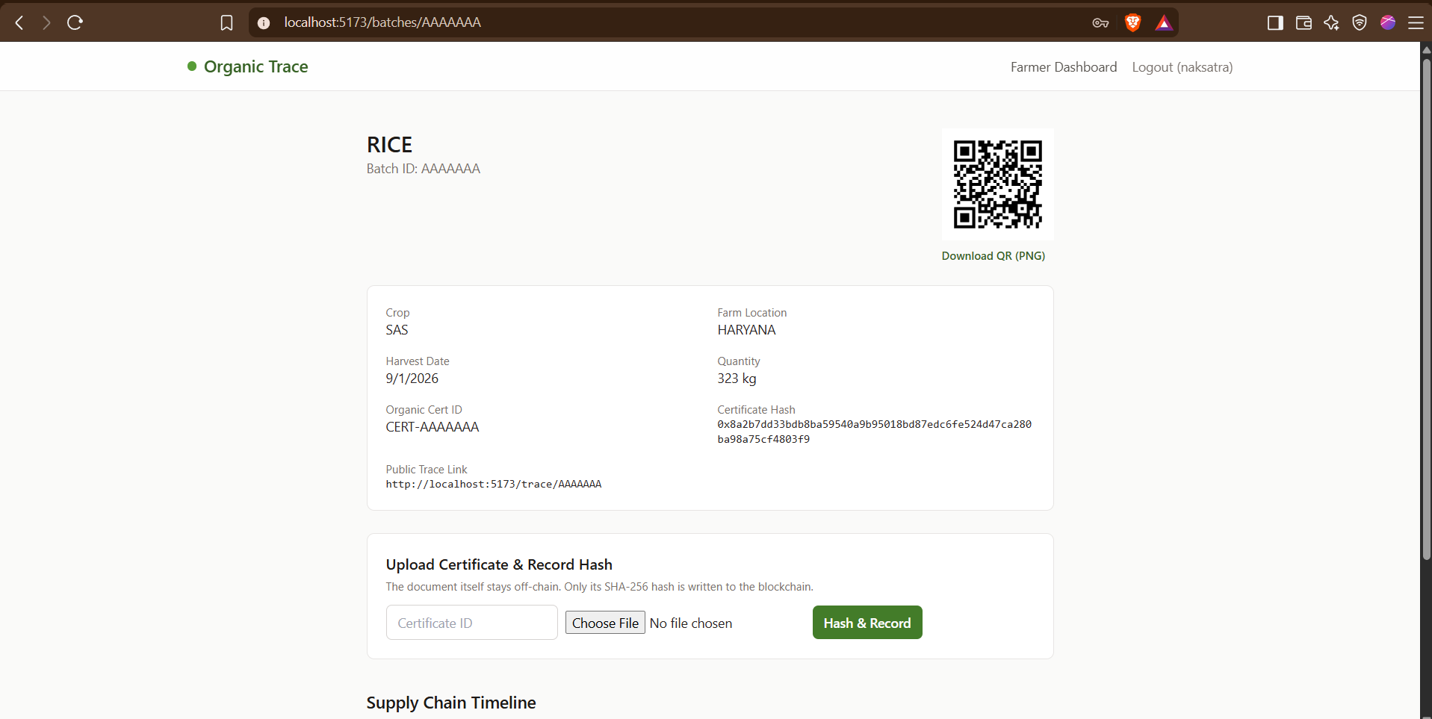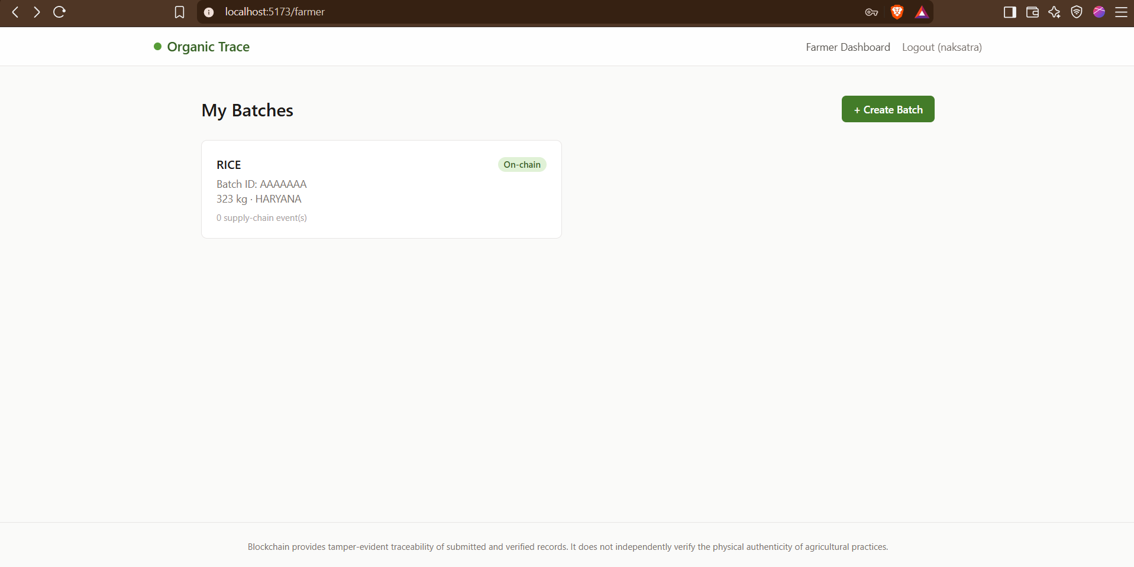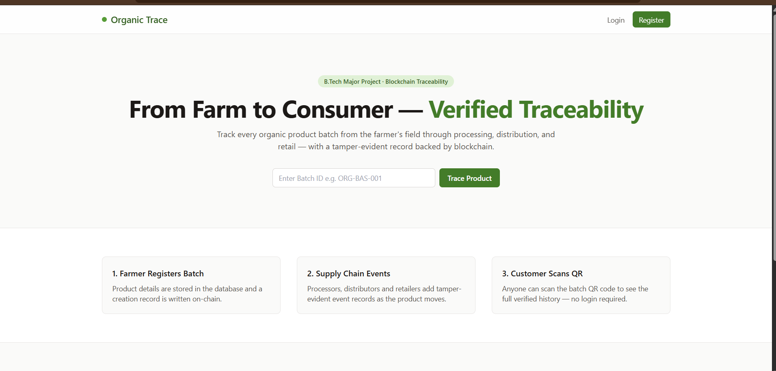

9. GANTT CHART
You can put this in the report as a proper table.
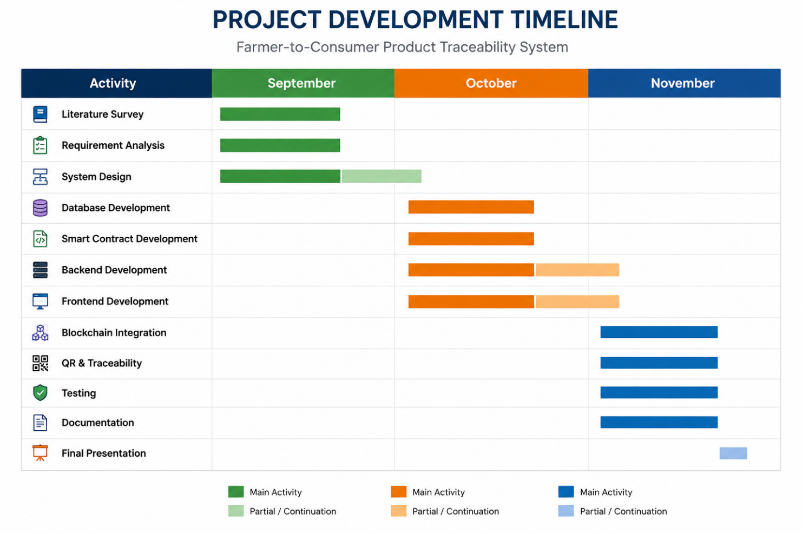 Important Milestones
- 8 September 2026: Quality & Feasibility Evaluation
- 14–19 September 2026: Mid-Term Evaluation
- 30 September 2026: Synopsis Submission
- 21 November 2026: End-Term Evaluation

10. RESPONSIBILITY CHART
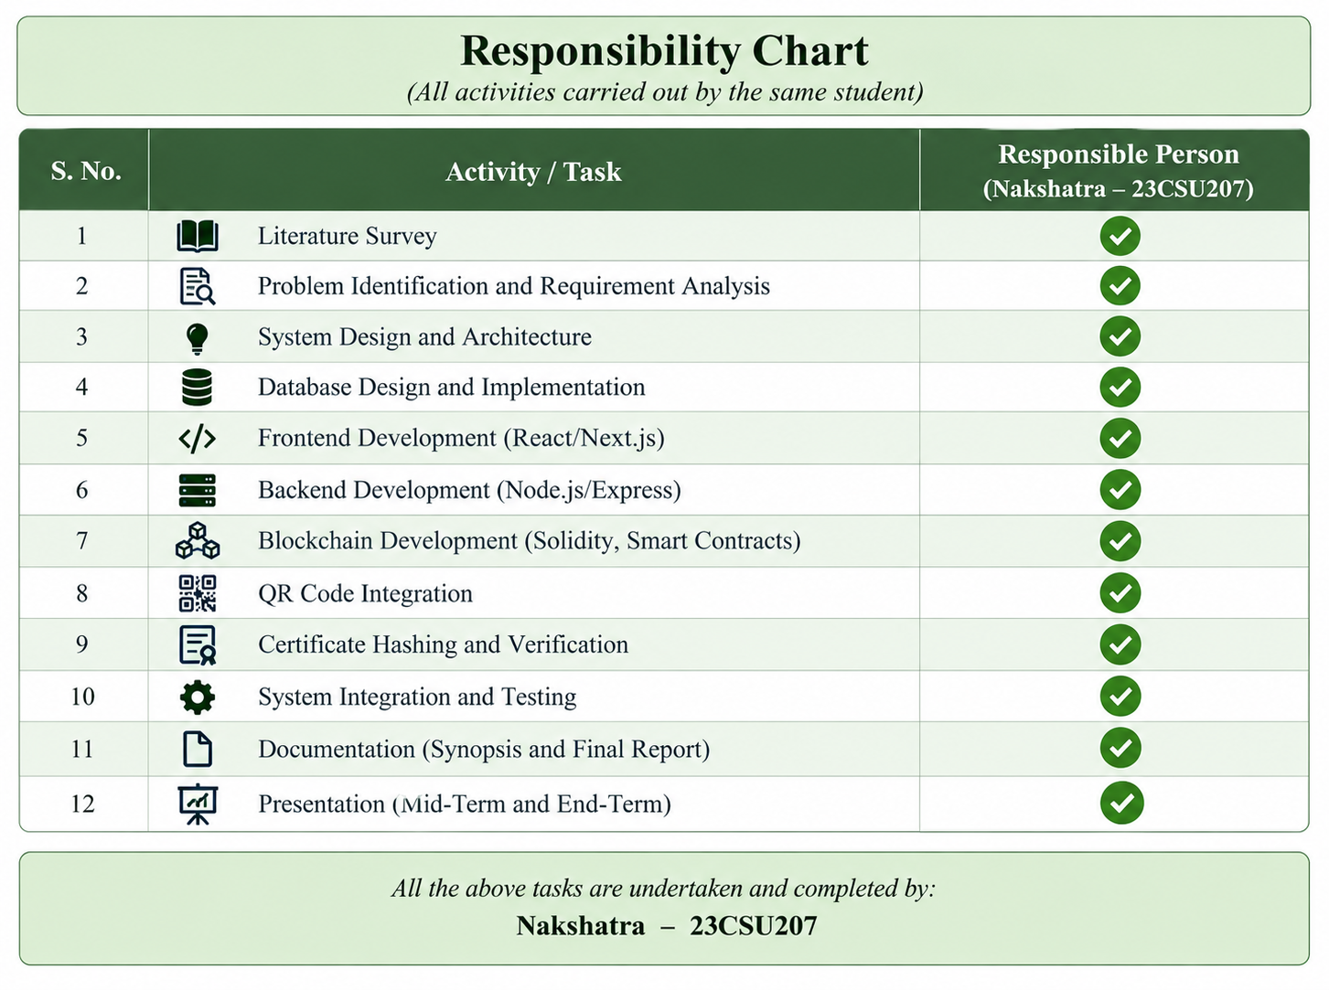

11. REFERENCES
For the synopsis, I recommend using real papers rather than generic websites.
References
[1] Feng, H., Wang, X., Duan, Y., Zhang, J., & Zhang, X. (2020). Applying blockchain technology to improve agri-food traceability: A review of development methods, benefits and challenges. Journal of Cleaner Production, 260, 121031.
[2] Prashar, D., Jha, N., Jha, S., Lee, Y., & Joshi, G. P. (2020). Blockchain-Based Traceability and Visibility for Agricultural Products: A Decentralized Way of Ensuring Food Safety in India. Sustainability, 12(8), 3497.
[3] Pan, L., Huo, B., & Hong, X. (2024). Blockchain traceability and agri-food appeal: A task-technology fit perspective. Food Quality and Preference, 105400.
[4] Rejeb, A., Rejeb, K., Treiblmaier, H., et al. (2026). Blockchain technology for food supply chain traceability using a systematic literature review and co-word analysis. Discover Sustainability.
[5] Vasileiou, M., Kyrgiakos, L. S., Kleisiari, C., et al. (2025). Digital Transformation of Food Supply Chain Management Using Blockchain: A Systematic Literature Review Towards Food Safety and Traceability. Business & Information Systems Engineering, 68, 919–946.
[6] Blockchain technology for a sustainable agri-food supply chain. British Food Journal, 123(11), 3471–3485, 2021.
[7] Blockchain and agricultural supply chains traceability: research trends and future challenges. Procedia Manufacturing, 42, 414–421, 2020.
[8] A peer-to-peer blockchain-based architecture for trusted and reliable agricultural product traceability. Decision Analytics Journal, 9, 100363, 2023.
[9] Blockchain technology characteristics essential for the agri-food sector: A systematic review. Food Control, 165, 110661, 2024.
[10] The impact of a blockchain-based food traceability system on the online purchase intention of organic agricultural products. Innovative Food Science & Emerging Technologies, 92, 103598, 2024.

